Need to initialize repository. I copied the following file from my work laptop onto my personal laptop and ran the proceeding git init command.

C:\Work\Projects\Angular\AngularDocumentation\git init

Enter the following to add all of the files (need period at the end to tell git what you wish to add)

C:\Work\Projects\Angular\AngularDocumentation\git add .

Commit to repository:

https://teamtreehouse.com/community/git-commit-a-m-new-message-commits-all-changes-so-what-happens-when-i-just-type-git-commit-m-new-message

use the following to add and commit:

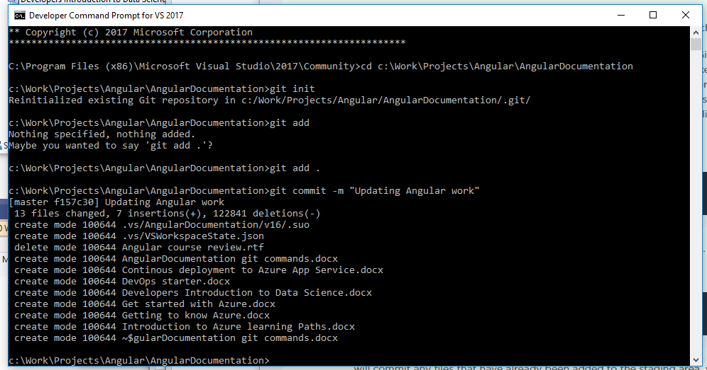

Show username in git and how to use:

https://docs.github.com/en/free-pro-team@latest/github/using-git/setting-your-username-in-git

Seems to be using the correct git username, but not sure where the Angular Documentation tracked branch is located, being tracked. To check out later:

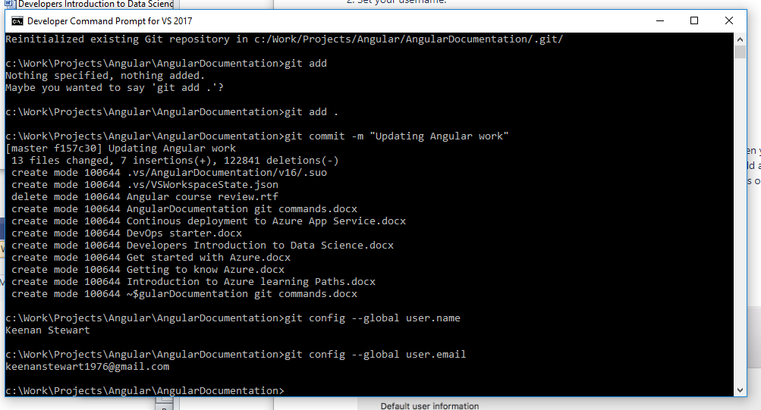

## Commit to git

git push origin master

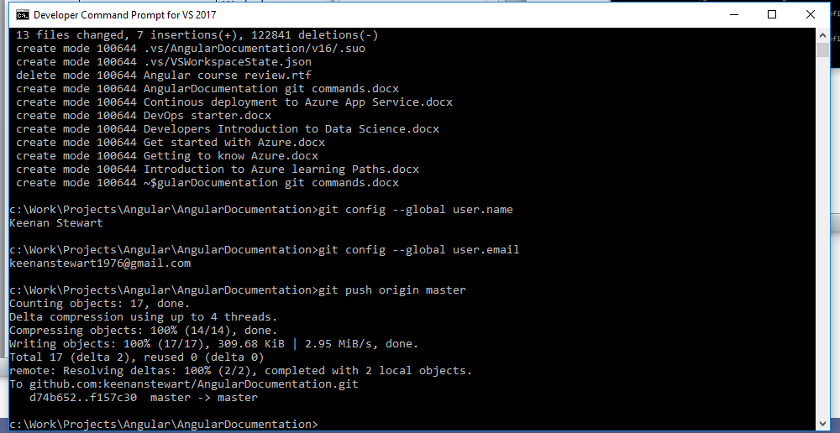

## Verify file updates

Verify file updates at: https://github.com/keenanstewart/AngularDocumentation